Task 6: Introduction to Cloud Networking. VPC
1. Log in to your AWS account, open the VPC dashboard, and create a new VPC named InstaVibeVPC with a custom IPv4 CIDR block (e.g., 10.0.0.0/16).
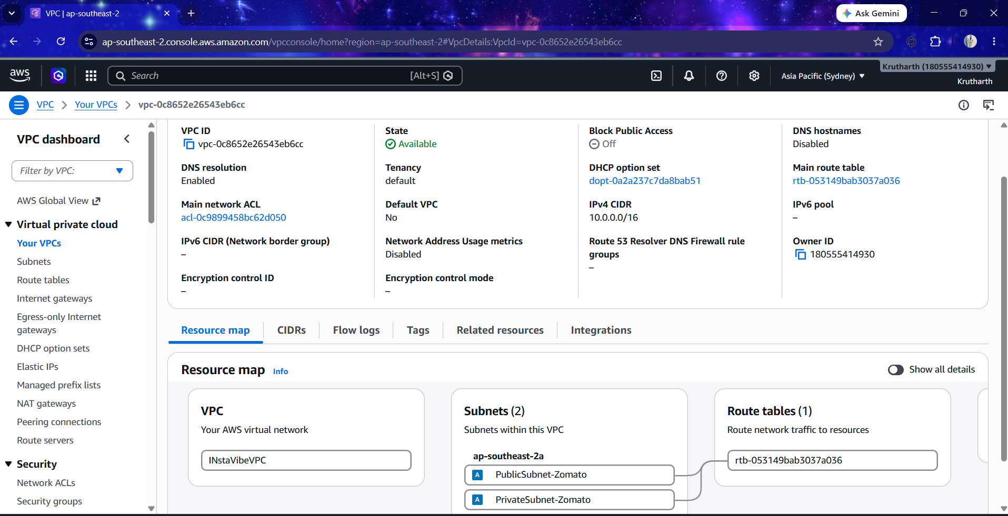

2. Inside your InstaVibeVPC, create two subnets: one public subnet (e.g., 10.0.1.0/24) for hosting a web server and one private subnet (e.g., 10.0.2.0/24) for backend services.<br><br><em><strong>Hint:</strong> Name your subnets as 'PublicSubnet-Zomato' and 'PrivateSubnet-Zomato' for clarity.</em>
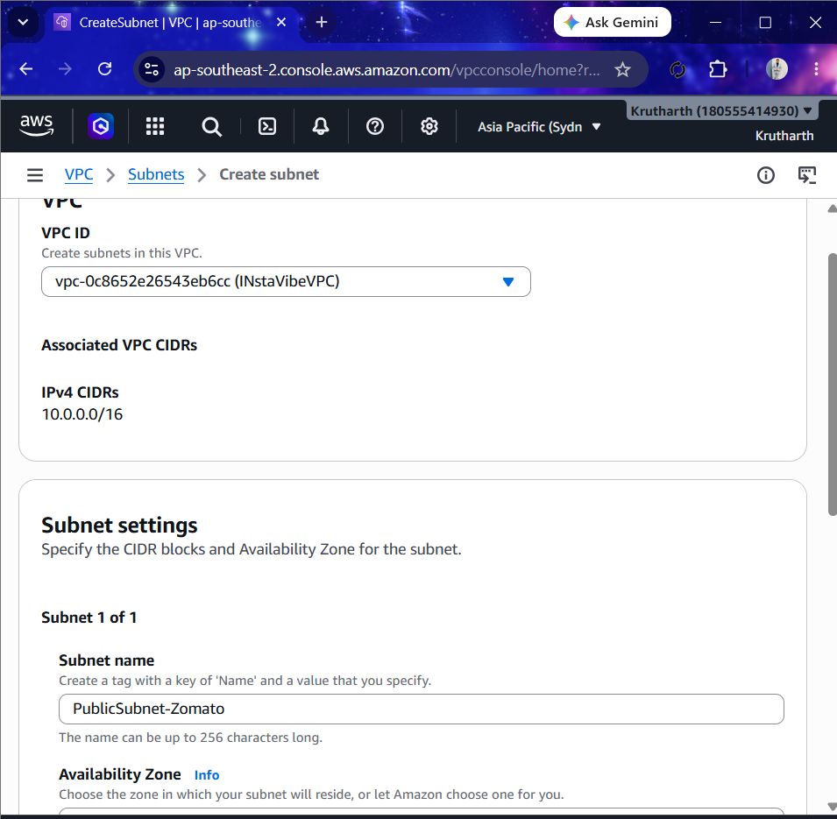
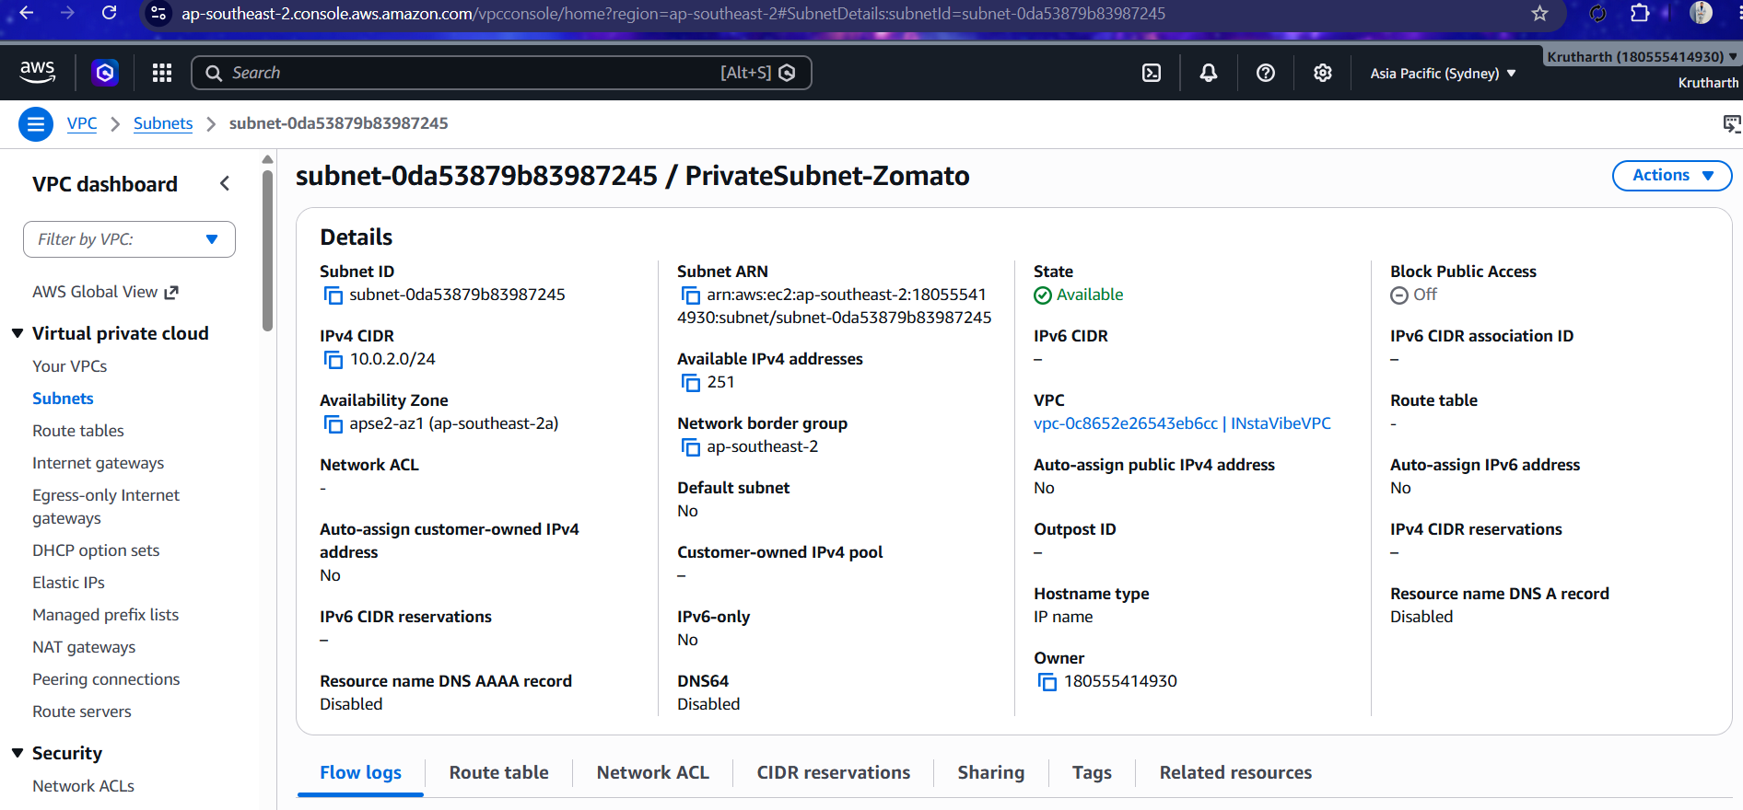

3. Configure an Internet Gateway and attach it to your InstaVibeVPC so that only the public subnet can access the internet, while the private subnet cannot.

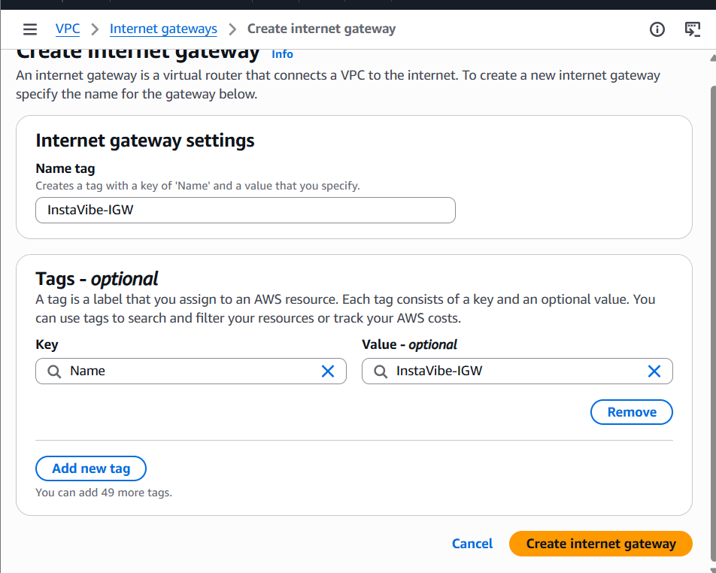
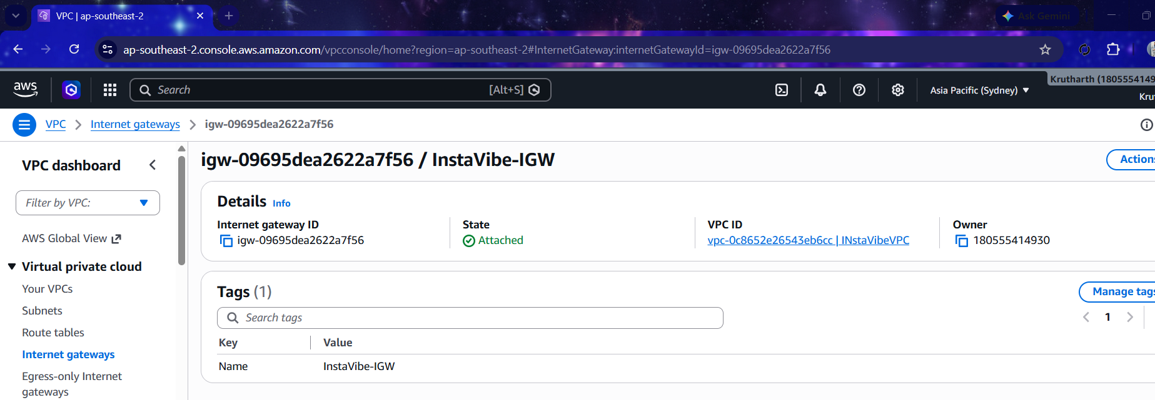

4. Set up route tables so that your public subnet routes traffic to the Internet Gateway, but your private subnet does not. Verify this by checking the route table associations.
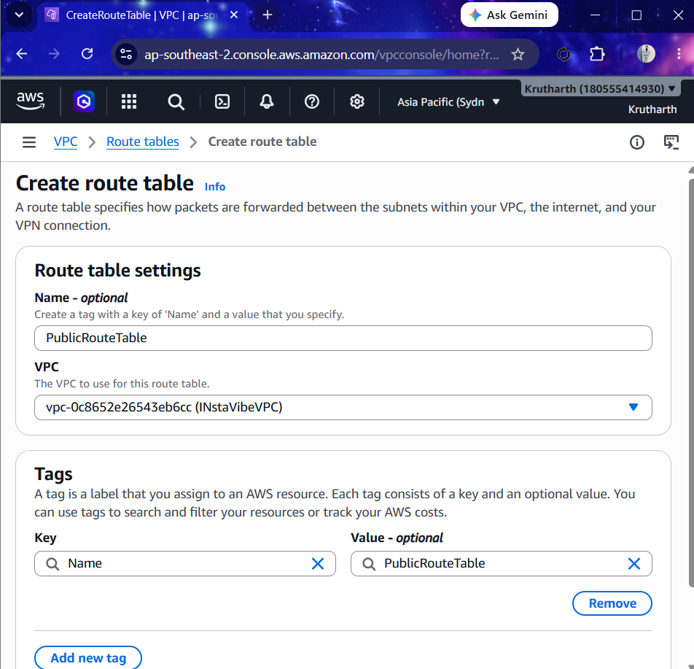
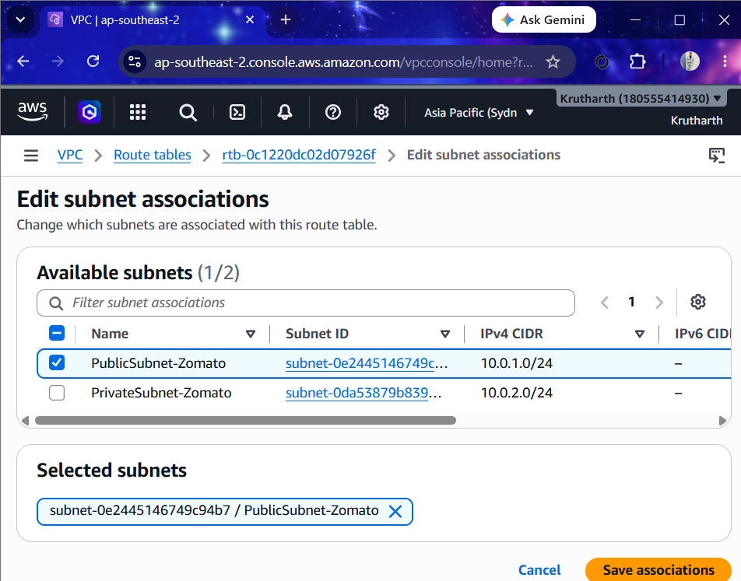

5. Draw a simple diagram (hand-drawn or using any online tool) showing your VPC, public subnet, private subnet, and Internet Gateway, and briefly explain in 3-4 lines how this setup is similar to how apps like Zomato separate their public user interface from their private databases.
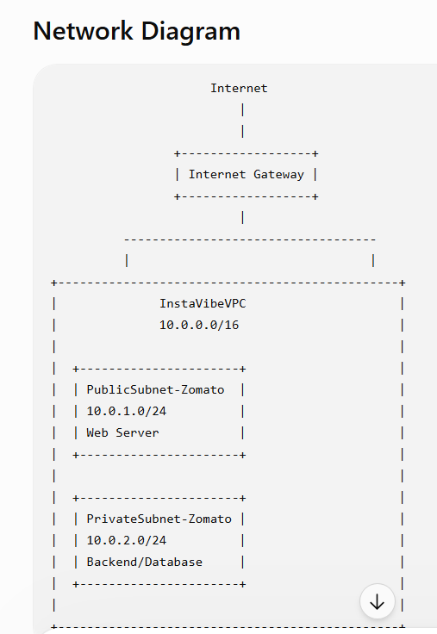
Apps such as Zomato separate their infrastructure into public and private networks for better security. The public subnet hosts web servers or application servers that users access over the internet. The private subnet contains backend services and databases, which are protected from direct internet access. This architecture improves security by ensuring that sensitive data is accessible only through the application layer.

